**SWIGGY DELIVERY ANALYSIS**

Analysis By :- AYUSH MISHRA

**Table of Contents**

1. Introduction
2. About Swiggy
3. Overview
4. Objectives
5. Data Sources
6. Methodology
7. Analysis and Findings

* Excel Analysis
* Power BI Report
* Tableau Visualizations
* Python (Pandas)

1. Implications
2. Conclusion
3. Appendices
4. Bibliograpfy

**1. Introduction**

Swiggy is India’s largest online food ordering and delivery platform, founded in 2014 by Sriharsha Majety, Nandan Reddy, and Rahul Jaimini. Headquartered in Bangalore, it operates in over 580 cities across India. Swiggy offers a wide range of services, including food delivery, Swiggy Instamart for quick commerce, and Swiggy Genie for same-day package deliveries. It has become a significant player in the food delivery market, competing with platforms like Zomato.

**2. About Swiggy**

**Swiggy is India’s largest online food delivery platform, founded in 2014, offering services like food delivery, quick commerce through Swiggy Instamart, and same-day package deliveries via Swiggy Genie. It operates in over 580 cities across India.**

**3. Overview**

**The project involves in-depth analysis of Swiggy delivery data using various tools and techniques including Excel, Python, Power BI, and Tableau. The objective is to gain insights into food delivery industry trends related to location, food types,restaurants, ratings, and price ranges.**

**4. Objectives**

**The main objectives of the project are:**

* **Develop a comprehensive City Map Table.**
* **Construct a Calendar Table utilizing the Column Datekey.**
* **Determine the Number of Restaurants based on Area and City.**
* **Compute the Count of Restaurants based on Average Ratings.**
* **Generate buckets based on the Average Price and determine the quantity of restaurants falling into each bucket.**
* **Analyze the Percentage of Restaurants with online delivery.**
* **Develop Charts based on Cuisines, City, and Ratings.**

**5. Data Sources**

**The primary data source for this project is Swiggy, which provides detailed information about restaurants, including location, ratings, price range, and amenities. Additional data sources may include public datasets or supplementary data collected from other sources.**

**6. Methodology**

**The methodology involves:**

* **Data extraction and cleaning using Excel and Python.**
* **Analysis using advanced Excel functions and Python (pandas).**

**Visualization using Power BI and Tableau to create interactive dashboards and visualizations**

**7. Analysis and Findings**

**Power BI Report**

* **Created interactive dashboards in Power BI to visualize and analyze Swiggy delivery data.**
* **Developed visualizations to explore trends in restaurant location, ratings, price range, and cuisine.**
* **Implemented slicers, filters, and drill-down functionality for interactive exploration of the data.**

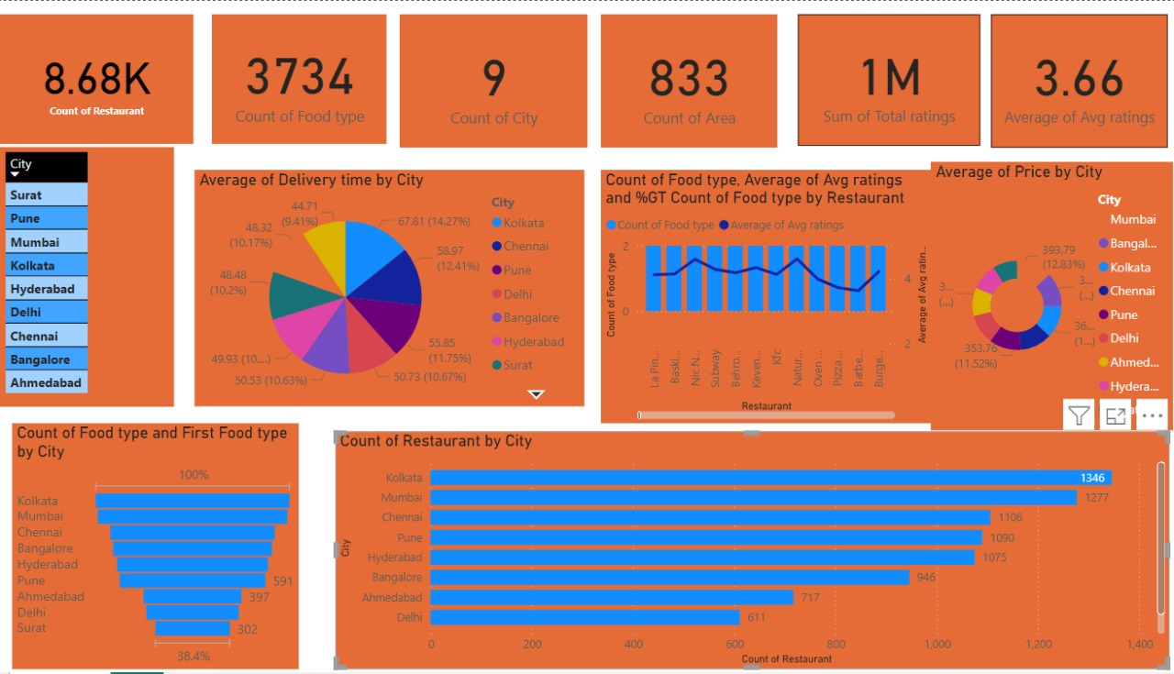

**Tableau Visualizations**

* Developed visualizations in Tableau to further explore and analyze Swiggy delivery data.
* Created interactive dashboards to visualize trends in city, ratings

Used advanced visualization techniques such as bar graph to uncover insights into the data

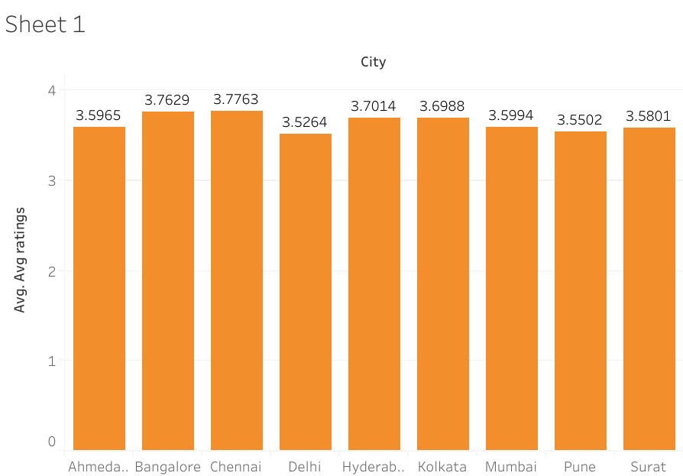

**Python Analysis using pandas**

* Utilized advanced python functions for data cleaning, manipulation, and visualization.
* Developed charts and graphs to visualize delivery data by location, ratings, price range, and cuisine.
* Conducted statistical analysis to identify trends and patterns in the data.

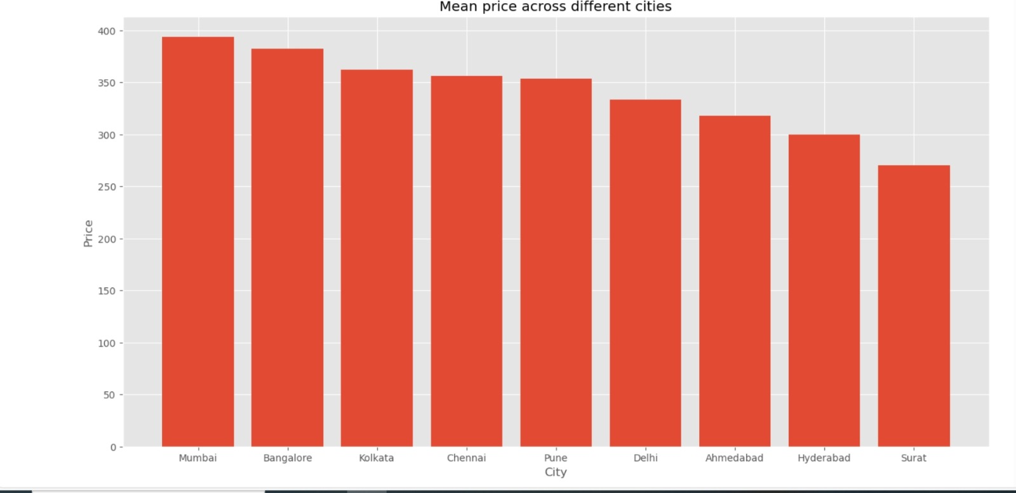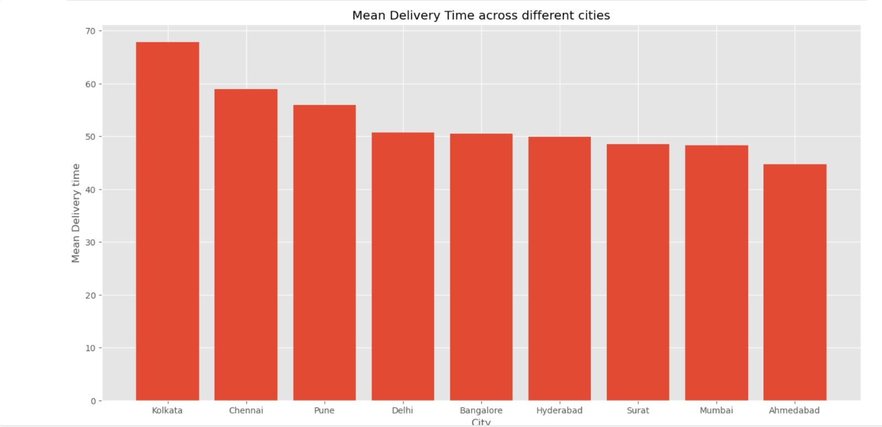

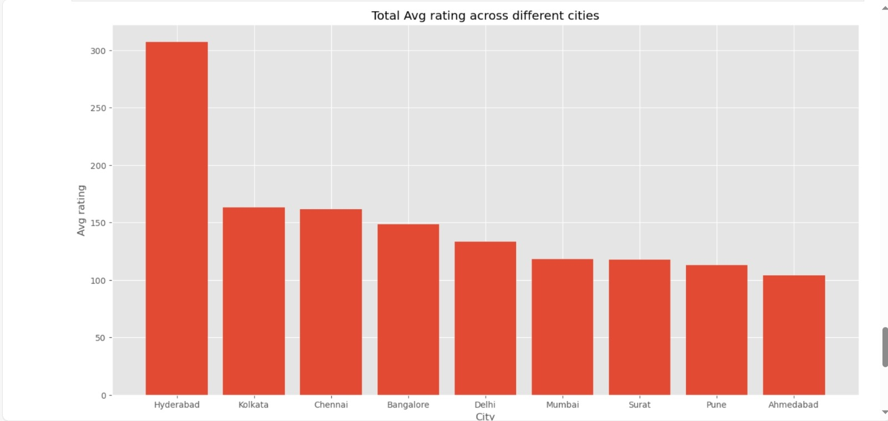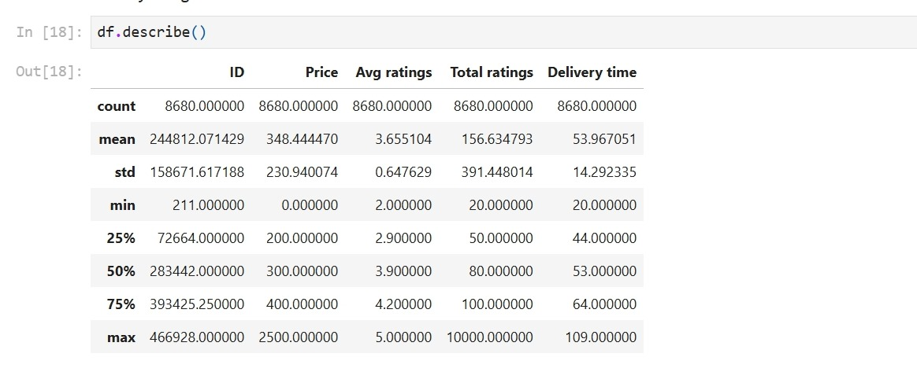

**8. Implications**

The insights generated from this analysis have significant implications for stakeholders within the delivery industry. These include:

* Identifying popular restaurant locations and cuisines.
* Understanding delivery timing based on Area and City.
* Analyzing customer preferences and satisfaction levels.
* Informing marketing strategies, menu planning, and business expansion decisions.

Why is swiggy declining?

Swiggy has faced challenges due to increased competition, high operational costs, and regulatory hurdles. The food delivery market is highly competitive, with rivals like Zomato and new entrants constantly vying for market share. Additionally, maintaining a large delivery fleet and ensuring timely deliveries add to the operational expenses. Regulatory changes, such as new labor laws, have also impacted their cost structure. These factors combined have made it difficult for Swiggy to maintain profitability.

How can swiggy revive!!!

Swiggy can revive its business by diversifying into new areas like grocery delivery and cloud kitchens to create additional revenue streams. Implementing cost optimization strategies through efficient logistics and automation can help reduce operational expenses. Enhancing customer experience with faster deliveries, better service, and personalized offers can boost loyalty. Additionally, leveraging data analytics to optimize delivery routes and predict demand can improve efficiency and customer satisfaction.

**9. Conclusion**

In conclusion, the swiggy food delivery Analysis project provides valuable insights into the food delivery industry landscape. By leveraging advanced analytics techniques and visualization tools, we have gained valuable insights that can inform decision-making and strategy development within the industry. The detailed analysis and visualizations presented in this report offer a comprehensive understanding of food delivery trends and customer preferences, paving the way for data-driven decision-making in the food delivery industry.

**10. Appendices**

- Appendix A: Screenshots of python

- Appendix B: Power BI Dashboards

- Appendix C: Tableau Visualizations

- Appendix D: Raw Data Sets

- Appendix E Code Snippets

1. Bibliograpfy

Dataset: Kaggle .com

Analysis softwares : Anaconda , MS – excel

Visualization softwares :- Power BI , Tabuleau

THANK YOU